ECON 100 - Review Session 2

# Test Questions on Macroeconomics

## Multiple-choice Questions

1. Rules of GDP
2. Unemployment rate (how to calculate that, how to calculate participation rate, how to calculate cyclical unemployment)
3. Rules of GDP (Real and nominal)
4. Understanding different types of workers
5. Being able to use the price indexes (GDP deflators, CPI, grandfather-type problem)
6. GDP question
7. What is included and not included in GDP
8. Understanding the difference between real and nominal
9. Application question of Real vs Nominal
10. Grandfather-type problem (using CPI to compare a current wage to a past wage to see which one’s better)
11. Fisher Equation problem (HW)
12. Understanding GDP
13. Understanding different types of workers
14. Understanding the rules of GDP (comes from multiple quizzes questions)
15. Understanding different types of workers
16. Labour supply and demand
17. Two period consumer model problem (Up or down arrows, like the recitation)
18. Savings and investment in an open economy (have graph next to you: savings vs. investment; autarky interest rate vs. world interest rate)
19. “Which of the following is not true about an economy with the real interest rate below the autarky interest rate?” -Verbatim question
20. Two-period consumer, Up/Down arrows or ? ambiguous
21. National Savings
22. Labor supply and demand question
23. Savings and investment in an open economy
24. Marginal analysis type problem (using UCC calculate marginal cost)
25. Two period consumer model problem
26. Savings/investment supply/demand in the investment/capital market
27. Solow growth model (will be a short answer about solow@end, might wanna check that one out first)
28. Solow growth model
29. Solow growth model
30. Solow growth model
31. Aggregate supply and demand (understanding curves)
32. Search and matching model unemployment type question (4 fill in the blanks, separations rate, wage/payroll tax, unemployment benefits (b), frequency of job offers (p))
33. Same as 32.
34. Understanding Aggregate supply and demand
35. Aggregate supply and demand (understanding curves)
36. Aggregate supply and demand
37. Different sides of economics (neoclassical, keynesian, supply side, Reaga-nomics, how they feel about personal income tax cuts.
38. “Whenever there’s a policy taken, there’s gonna be additional effects to that policy. Understand the positive and negative effects of them “-Jimmy
39. **\*tough one\*** About the Phillips curve and its connection to monetary policy. “Think about how monetary affects prices and unemployment through the Phillips curve”
40. How monetary policy can affect net exports
41. Understanding roles of money
42. Curves in aggregate supply and demand, moving along, shifts
43. Aggregate supply and demand
44. Accommodating monetary policy, spending more money, worried about crowding out effects, [expansionary monetary policy with expansionary fiscal policy], [contractionary monetary policy with contractionary fiscal policy] (to try to keep inflation rates low).
45. Money supply accounting problem. (Excess reserves, deposits, etc.)
46. Up/Down arrow type questions that deal with aggregate supply and demand or policy. (Considering wealth effect, income effect, and exchange rates effects on consumption, aggregate demand, prices, interest rates and other aspects)
47. Same as 46.
48. Understanding gov’t and tax multipliers.
49. Same as 46. (gov’t spending & tax cuts)
50. Same as 46. (price and aggregate demand SHAN’T go in same direction)

## Short-answer Questions

1. One of them is about the Solow growth model
2. A bunch of calculations

# Need to knows

* Need to know how to calculate unemployment
* How to calculate participation rate
* Equation for cyclical rate of unemployment: Cyclical = Unemployment - Natural
* National savings equation
* Fisher equation: 1 + i = (1 + r) * (1 + πe) ~~~ i = r + πe ----(day 15 recitation 3.3)
* How to set up arrows in two-period consumer model (Change in current income, change in future income, change in interest rate)
  + Substitution and wealth effect, depends on net debtor or net saver
* Put a graph together for savings and investment in an open economy
* Relationship between savings and investment and relationship between Autarky interest rate and world interest rate.
* Solow Growth Model: ”Info from recitation 3, (problem #5) will be on the exam.” He gives all the equations and explains what they are, you just have to be comfortable enough to understand. Need to be able to answer 3 questions: Economic growth in the short and long run (in long run, hits steady state and growth goes down to zero), and what happens to consumption in the steady state. (growth is 0 eventually at s.s.)
* If steady state goes down, you have negative growth in short run
* Consumption is positively correlated to total factor productivity
* If population growth or depreciation rate go up consumption goes down.
* Do calculations for solow growth model and solve for steady state capital to labor ratio.
* What’s the most important factor, unbounded as far as continued economic growth (=technology)
* We need to know the value of employment, the value of unemployment and the reservation wage when the different variables change in the Search and Matching model
* Policy chapter: Connected to question 37. Understanding what each side believed and proposed.
* Money: Wealth effect, interest rate effect, exchange rate effect.
* TIP: Do not pick an answer with price and aggregate demand both going in the same direction
* Question 46-ish:  
   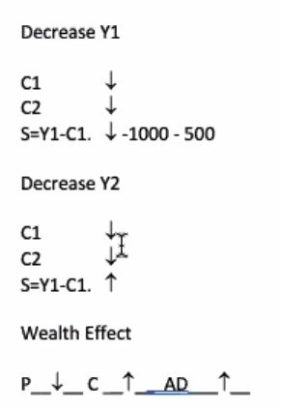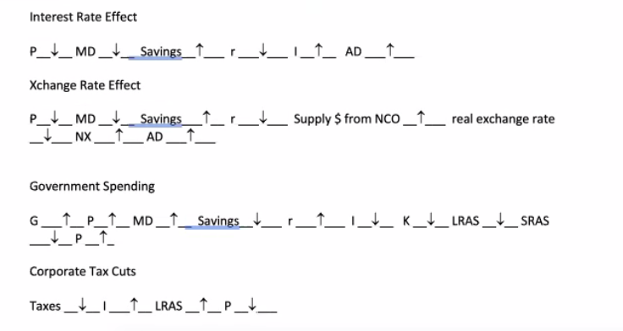

# Recommendation for Studying

Study mostly recitations and Extra Credit Questions

